MINISTRY OF EDUCATION AND SCIENCE OF THE REPUBLIC OF KAZAKHSTAN

INTERNATIONAL INFORMATION TECHNOLOGY UNIVERSITY

FACULTY OF INFORMATION TECHNOLOGIES

Department of Computer engineering and information security

COURSE PROJECT

Major 5B070400 – Computer systems and software engineering

Discipline Web technologies

Topic: _______________Clothes store_______________________

|  |  |  |
| --- | --- | --- |
| STUDENT: | IT2CCO-2112-Nursultanov A.E.  (group and student name) | _____________  (signature) |
| SUPERVISOR: | Assistant-professor  Mukazhanov N.K.  (position, name) | _____________  (signature) |

Almaty 2021

# **Content**

Introduction

Main part

1 Theoretical part

2 Design

3 Implementation (creation of website)

Conclusion

References

**Introduction**

The project "N.A. Street wear" is a website where you can get acquainted with the clothing product, find out the size, quality and buy it with home delivery

The site's interface is based on HTML, CSS, and Js.

Done yet at the moment only Moke up.

**Main part**

1 Theoretical part

2 Design

3 Implementation (creation of website)

*Theoretical part:*

The definition of HTML is **HyperText Markup Language**.

* *HyperText* is the method by which you move around on the web — by clicking on special text called **hyperlinks** which bring you to the next page. The fact that it is *hyper* just means it is not linear — i.e. you can go to any place on the Internet whenever you want by clicking on links — there is no set order to do things in.
* *Markup* is what **HTML tags** do to the text inside them. They mark it as a certain type of text (*italicised* text, for example).
* HTML is a *Language*, as it has code-words and syntax like any other language.

What is **CSS**?

* CSS stands for Cascading Style Sheets
* CSS describes how HTML elements are to be displayed on screen, paper, or in other media
* CSS saves a lot of work. It can control the layout of multiple web pages all at once
* External stylesheets are stored in CSS files

What is **JS**?

* JavaScript is a language that allows you to apply complex things on a web page-every time something more than just its static display occurs on a web page- displaying periodically updated content, or interactive maps, or animation of 2D/3D graphics, or scrolling videos in the player, etc. — you can be sure that most likely it was not without JavaScript. This is the third layer of the layer cake of standard web technologies, two of which (HTML and CSS) we have disclosed in detail in other parts of the tutorial.

*Implementation (creation of website):*

HOME PAGE:



Qality :

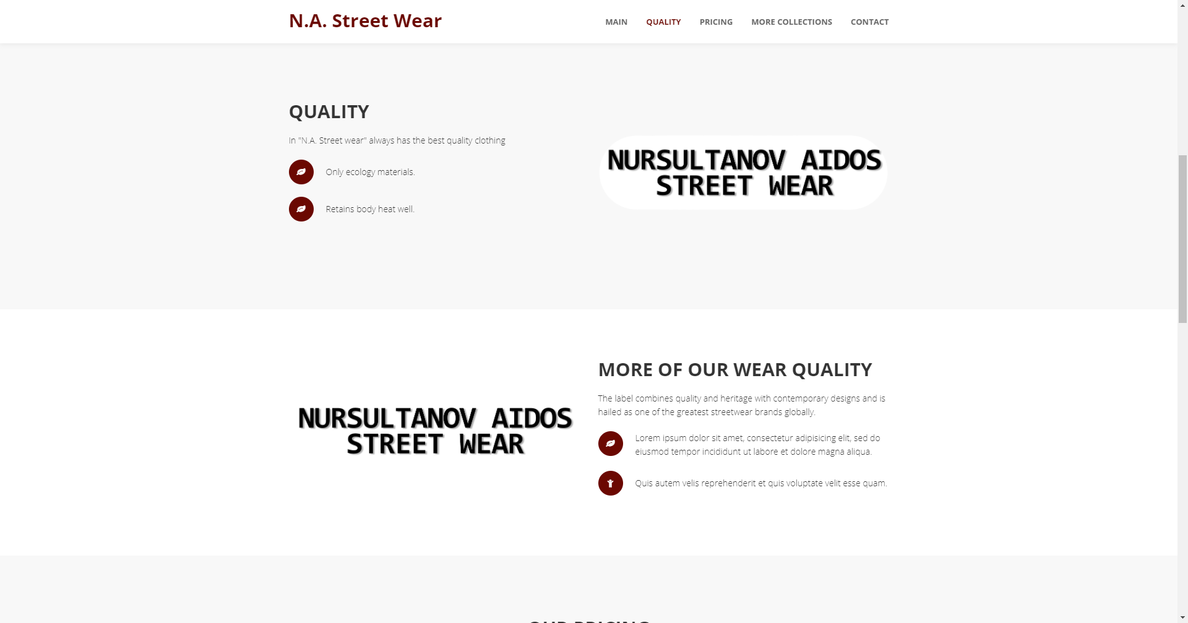

Price:

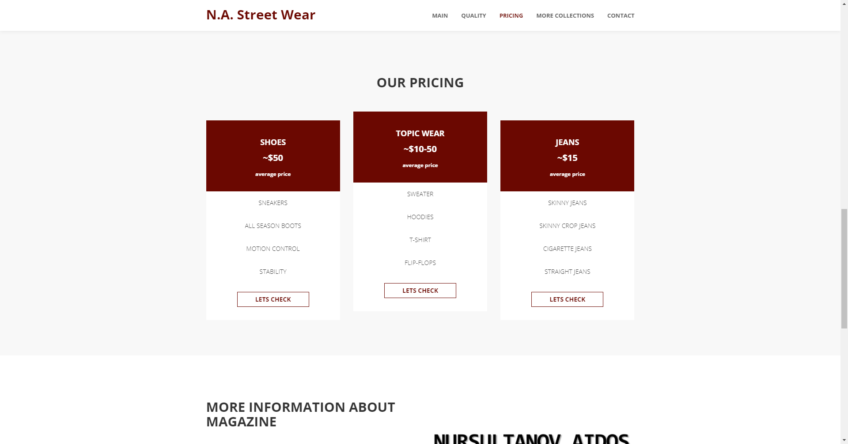

ABOUT and CONTACT PAGE:

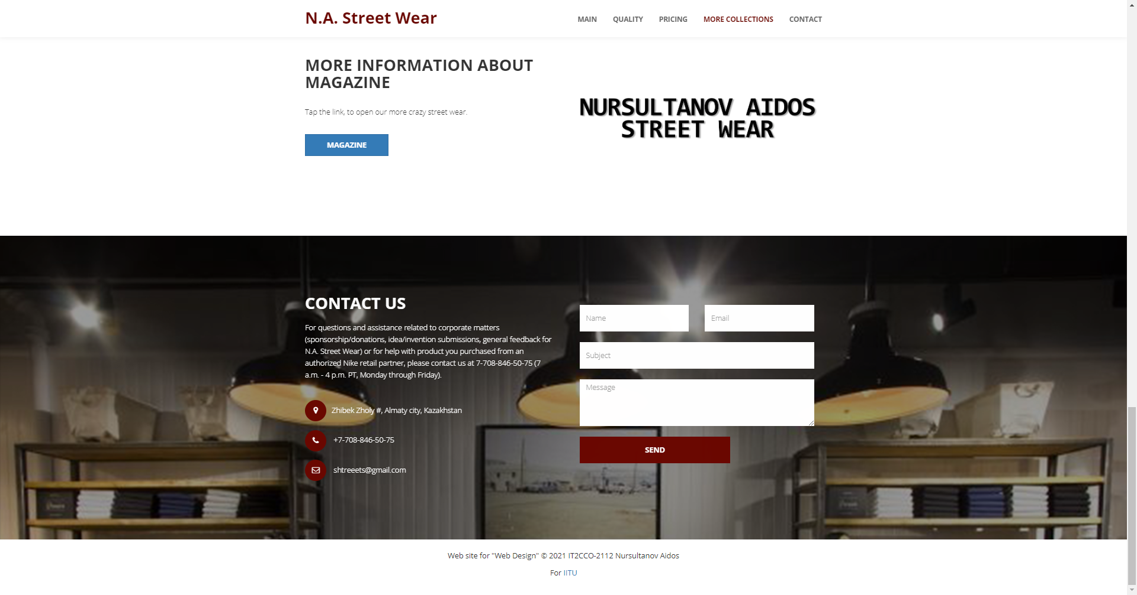

PROJECT STRUCTURE:

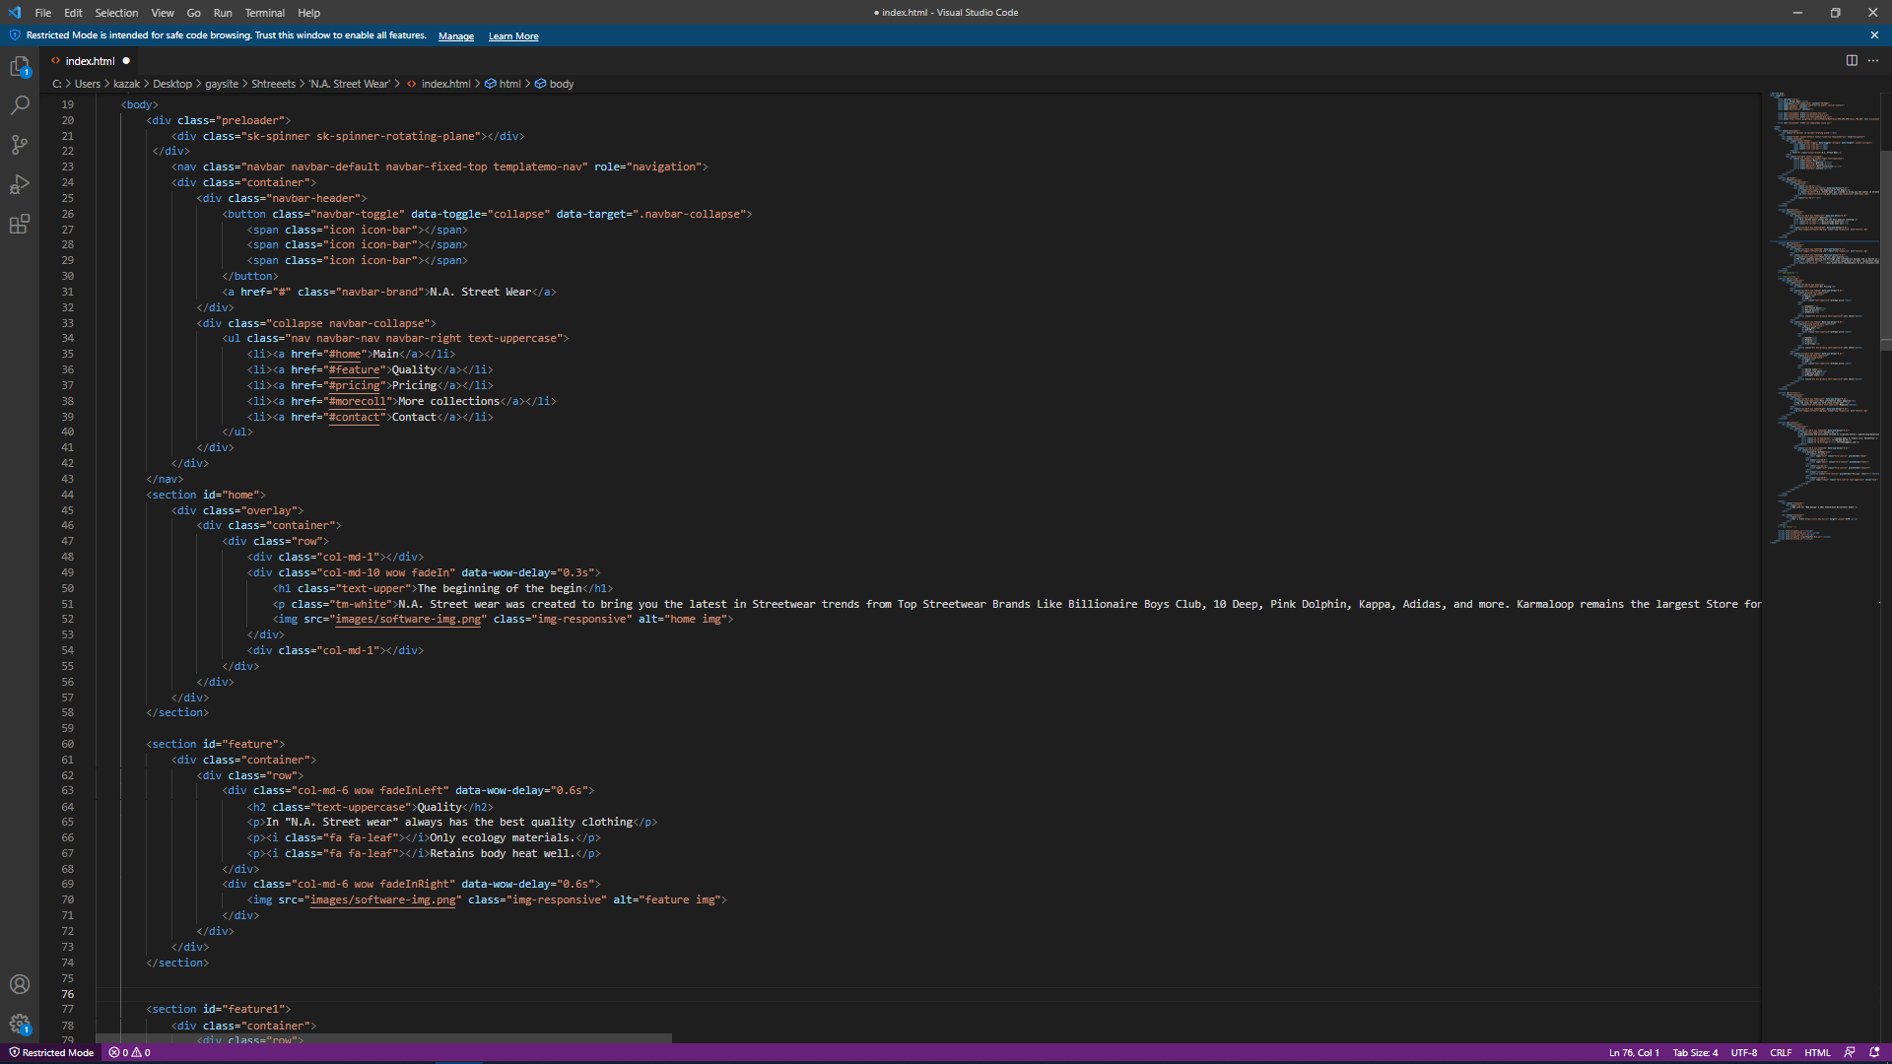

**Conclusion**

The N.A. Street wear ticket features:

1. There are clothes in the store:
2. Main front page
3. Product quality
4. Prices
5. More information about the store
6. Contacts